**Features:**

* Supports 41.2Gbps aggregate bit rates
* Uncooled 4x10.3Gbps CWDM transmitter
* High-sensitivity PIN-TIA receiver
* Up to 40km on SMF
* Duplex LC receptacles
* Hot pluggable QSFP+ form factor
* Power dissipation < 3.5W
* All-metal housing for superior EMI performance
* RoHS6 compliant (lead free)
* Operating case temperature:
* Commercial: 0ºC to +70°C

**Applications:**

* 40GBASE-ER4
* InfiniBand QDR and DDR interconnects
* 40G Telecom connections

**Specification:**

* + **Module Block Diagram**

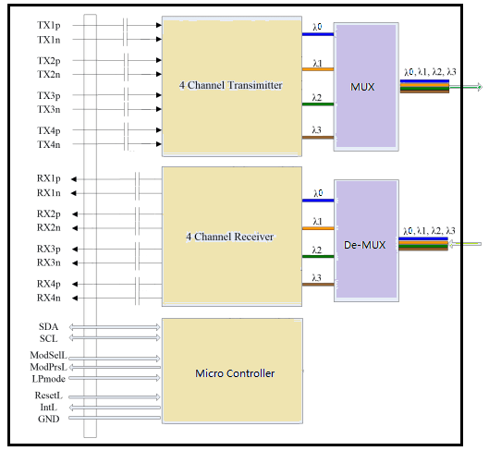

|  |  |  |  |  |  |  |
| --- | --- | --- | --- | --- | --- | --- |
| **Parameter** | **Symbol** | **Min.** | **Typical** | **Max.** | **Unit** | **Note** |
| **Transmitter Section** | | | | | | |
| Lane Centre Wavelength (range) | λ0 | 1264.5 | 1271 | 1277.5 | nm |  |
| λ1 | 1284.5 | 1291 | 1297.5 | nm |  |
| λ2 | 1304.5 | 1311 | 1317.5 | nm |  |
| λ3 | 1324.5 | 1331 | 1337.5 | nm |  |
| Spectral Width (-20dB) | Δλ |  |  | 1 | nm |  |
| Side Mode Suppression Ratio | SMSR | 30 |  |  | dB |  |
| Average Optical Power per Lane | Pout | -2.7 |  | +5 | dBm | 1 |
| OMA Power per Lane | OMA | -4 |  | 3.5 | dBm | 1 |
| Laser Off Power per Lane | Poff | - | - | -30 | dBm |  |
| Extinction Ratio | ER | 3.5 | - | - | dB | 2 |
| Relative Intensity Noise | RIN | - | - | -128 | dB/Hz |  |
| Optical Return Loss Tolerance |  | - | - | 20 | dB |  |
| Transmitter eye mask definition  {X1, X2, X3, Y1, Y2, Y3} | Compliant with IEEE802.3ba  {0.25, 0.4, 0.45, 0.25, 0.28, 0.4} | | | | | 2 |
| **Receiver Section** | | | | | |  |
| Lane Center Wavelength (range) | λ0 | 1264.5 |  | 1277.5 | nm |  |
| λ1 | 1284.5 |  | 1297.5 | nm |  |
| λ2 | 1304.5 |  | 1317.5 | nm |  |
| λ3 | 1324.5 |  | 1337.5 | nm |  |
| Average Receiver Power per Lane | RXPX | -13.7 |  | 2.3 | dBm | 3 |
| OMA Sensitivity per Lane | RXsens |  |  | -11.5 | dBm | 3 |
| Los Assert | LOSA | -30 | - | - | dBm |  |
| Los Dessert | LOSD | - | - | -16 | dBm |  |
| Los Hysteresis | LOSH | 0.5 | - | 5 | dB |  |
| Overload per Lane | Pin-max | - | - | 2.3 | dBm | 3 |
| Receiver Reflectance |  | - | - | -12 | dB |  |
| Damage Threshold per Lane |  | - | - | 3.5 | dBm |  |

* + **Optical Characteristics**

**Notes:**

1. The optical power is launched into 9/125µm SMF.

2. Measured with a PRBS 231-1 test pattern @10.3125Gbps.

3. Measured with a PRBS 231-1 test pattern @10.3125Gbps, ER=4dB, BER <10-12.

* + **Electrical Characteristics**

|  |  |  |  |  |  |  |
| --- | --- | --- | --- | --- | --- | --- |
| **Parameter** | **Symbol** | **Min.** | **Typical** | **Max.** | **Unit** | **Note** |
| **Transmitter Section** | | | | | |  |
| Input Differential Impedance | Rin | 90 | 100 | 110 | Ω |  |
| Differential Data Input Swing | Vin PP | 180 |  | 1000 | mV | 1 |
| **Receiver Section** | | | | | |  |
| Differential Data Output Swing | Vout PP | 300 |  | 850 | mV |  |

**Notes:**

**1.** Connected directly to TX data input pins. AC coupling from pins into laser driver IC.

* + **Absolute Maximum Ratings: (TC=25℃)**

|  |  |  |  |  |
| --- | --- | --- | --- | --- |
| **Parameter** | **Symbol** | **Min.** | **Max.** | **Unit** |
| Storage Temperature | TST | -40 | +85 | ℃ |
| Operating Temperature | TIP | 0(-40) | +70(+85) | ℃ |
| Input Voltage | TCC | 0 | +5 | V |

* + **Recommended Operating Environment:**

|  |  |  |  |  |  |  |
| --- | --- | --- | --- | --- | --- | --- |
| **Parameter** | **Symbol** | **Min.** | **Typical** | **Max.** | **Unit** | |
| Supply Voltage | VCC | +3.0 | +3.3 | +3.6 | V | |
| Operating Temperature | TOP | 0 | - | +70 | | ℃ |
| Power Supply Voltage | VCC | 3.13 | 3.3 | 3.46 | | V |
| Power Supply Current | ICC |  | 500 | 1000 | | mA |
| Power Dissipation | PD |  |  | 3.5 | | W |
| Operating Case Temperature | TC | 0 |  | +70 | | °C |
| Aggregate Data Rate | - |  | 41.25 |  | | Gbps |
| Bit Rate per Lane | BR |  | 10.3125 |  | | Gbps |

* + **Timing Characteristics:**

|  |  |  |  |  |  |
| --- | --- | --- | --- | --- | --- |
| **Parameter** | **Symbol** | **Min.** | **Typical** | **Max.** | **Unit** |
| TX_DISABLE Assert Time | t_off |  | 3 | 10 | usec |
| TX_DISABLE Negate Time | t_on |  | 0.5 | 1 | msec |
| Time to Initialize Include Reset of TX_FAULT | t_int |  | 30 | 300 | msec |
| TX_FAULT from Fault to Assertion | t_fault |  | 20 | 100 | usec |
| TX_DISBEL Time to Start Reset | t_reset | 10 |  |  | usec |
| Receiver Loss of Signal Assert Time (Off to On) | TA,RX_LOS |  |  | 100 | usec |
| Receiver Loss of Signal Assert Time (On to Off) | Td,RX_LOS |  |  | 100 | usec |

* + **Serial ID Memory Contents:**

|  |  |  |  |
| --- | --- | --- | --- |
| **Data Address** | **Length**  **(Byte)** | **Name of**  **Length** | **Description and Contents** |
| Base ID Fields | | | |
| 0 | 1 | Identifier | Type of Serial transceiver (03h=SFP28) |
| 1 | 1 | Reserved | Extended identifier of type serial transceiver (04h) |
| 2 | 1 | Connector | Code of optical connector type (07=LC) |
| 3-10 | 8 | Transceiver | Gigabit Ethernet 1000Base-SX & Fiber Channel |
| 11 | 1 | Encoding | 8B10B (01h) |
| 12 | 1 | BR,Nominal | Nominal baud rate, unit of 100Mbps |
| 13-14 | 2 | Reserved | (0000h) |
| 15 | 1 | Length(9um) | Link length supported for 9/125um fiber, units of 100m |
| 16 | 1 | Length(50um) | Link length supported for 50/125um fiber, units of 10m |
| 17 | 1 | Length(62.5um) | Link length supported for 62.5/125um fiber, units of 10m |
| 18 | 1 | Length(Copper) | Link length supported for copper, units of meters |
| 19 | 1 | Reserved |  |
| 20-35 | 16 | Vendor Name | SFP28 vendor name |
| 36 | 1 | Reserved |  |
| 37-39 | 3 | Vendor OUI | SFP28 transceiver vendor OUI ID |
| 40-55 | 16 | Vendor PN | Part Number |
| 56-59 | 4 | Vendor rev | Revision level for part number |
| 60-62 | 3 | Reserved |  |
| 63 | 1 | CCID | Least significant byte of sum of data in address 0-62 |
| Extended ID Fields | | | |
| 64-65 | 2 | Option | Indicates which optical SFP28 signals are implemented  (001Ah = LOS, TX_FAULT, TX_DISABLE all supported) |
| 66 | 1 | BR, max | Upper bit rate margin, units of % |
| 67 | 1 | BR, min | Lower bit rate margin, units of % |
| 68-83 | 16 | Vendor SN | Serial number (ASCII) |
| 84-91 | 8 | Date code | Manufacturing date code |
| 92-94 | 3 | Reserved |  |
| 95 | 1 | CCEX | Check code for the extended ID Fields (addresses 64 to 94) |
| Vendor Specific ID Fields | | | |
| 96-127 | 32 | Readable | specific date, read only |

* + **Digital Diagnostic Monitoring Functions**

2-wire serial bus address 1010001X (A2h) is used to access measurement of transceiver temperature, internally measured supply voltage, TX bias current, TX optical output power and RX optical input power which are shown in table 1. Each diagnostic parameter has a corresponding high alarm, low alarm, high warning and low warning threshold which are shown in table 2.

Table 1. Diagnostic Parameters

|  |  |  |  |  |  |  |
| --- | --- | --- | --- | --- | --- | --- |
| Diagnostic Parameter | Range | | LSB | Accuracy | Address | Note |
| Min | Max |
| Transceiver Temperature  (Temp) | -50[℃] | +80[℃] | 1/256[℃] | ±3[℃] | 96-97 | A 16bit signed two’s complement value |
| Supply Voltage  (Voltage) | +3.0[V] | +3.6[V] | 100[㎶] | ±3[%] | 98-99 | A 16bit unsigned  integer |
| TX Bias Current  (Bias) | 3[mA] | 95[mA] | 2.0[㎂] | ±10[%] | 100-101 | A 16bit unsigned  integer |
| TX Optical Output Power  (TX Power) | -2.7[dBm] | +5[dBm] | 0.1[㎼] | ±3 [dB] | 102-103 | A 16bit unsigned  integer |
| RX Optical Input Power  (RX Power) | -19.5[dBm] | +0[dBm] | 0.1[㎼] | ±3 [dB] | 104-105 | A 16bit unsigned  integer |

Table 2. Alarm and Warning Thresholds

|  |  |  |  |  |  |
| --- | --- | --- | --- | --- | --- |
| Parameter | Warning | | Alarm | | Unit |
| Low | High | Low | High |
| Transceiver Temperature  (Temp) | -10 | +80 | -20 | +90 | ℃ |
| Supply Voltage  (Voltage) | +3.13 | +3.47 | +3.0 | +3.6 | V |
| TX Bias Current  (Bias) | 5 | 85 | 3 | 95 | mA |
| TX Optical Output Power  (TX Power) | -2.7 | +5 | -3.5 | +6 | dBm |
| RX Optical Input Power  (RX Power) | -18.5 | +1 | -19.5 | +2 | dBm |

* + **Pin Assignment**

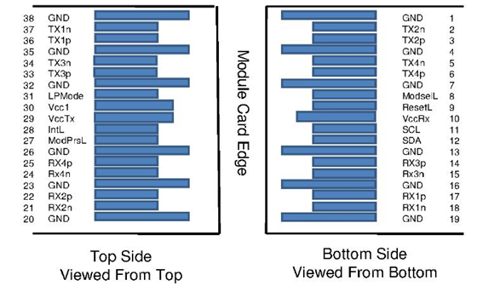

* + **Pin Description:**

|  |  |  |  |  |
| --- | --- | --- | --- | --- |
| **Pin** | **Symbol** | **Description** | **Plug Seq.** | **Notes** |
| 1 | Ground | Ground | 1 | 1 |
| 2 | Tx2n | Transmitter Inverted Data Input | 3 |  |
| 3 | Tx2p | Transmitter Non-Inverted Data Input | 3 |  |
| 4 | Ground | Ground | 1 | 1 |
| 5 | Tx4n | Transmitter Inverted Data Input | 3 |  |
| 6 | Tx4p | Transmitter Non-Inverted Data Input | 3 |  |
| 7 | Ground | Ground | 1 | 1 |
| 8 | ModSelL | Module Select | 3 |  |
| 9 | ResetL | Module Reset | 3 |  |
| 10 | VccRx | +3.3 V Power supply receiver | 2 | 2 |
| 11 | SCL | 2-wire serial interface clock | 3 |  |
| 12 | SDA | 2-wire serial interface data | 3 |  |
| 13 | Ground | Ground | 1 | 1 |
| 14 | Rx3p | Transmitter Non-Inverted Data Input | 3 |  |
| 15 | Rx3n | Transmitter Inverted Data Input | 3 |  |
| 16 | Ground | Ground | 1 | 1 |
| 17 | Rx1p | Transmitter Non-Inverted Data Input | 3 |  |
| 18 | Rx1n | Transmitter Inverted Data Input | 3 |  |
| 19 | Ground | Ground | 1 | 1 |
| 20 | Ground | Ground | 1 | 1 |
| 21 | Rx2n | Transmitter Inverted Data Input | 3 |  |
| 22 | Rx2p | Transmitter Non-Inverted Data Input | 3 |  |
| 23 | Ground | Ground | 1 | 1 |
| 24 | Rx4n | Transmitter Inverted Data Input | 3 |  |
| 25 | Rx4p | Transmitter Non-Inverted Data Input | 3 |  |
| 26 | Ground | Ground | 1 | 1 |
| 27 | ModPrsL | Module Present | 3 |  |
| 28 | IntL | Interrupt | 3 |  |
| 29 | VccTx | +3.3 V Power supply transmitter | 2 | 2 |
| 30 | Vcc1 | +3.3 V Power Supply | 2 | 2 |
| 31 | LPMode | Low Power Mode | 3 |  |
| 32 | Ground | Ground | 1 | 1 |
| 33 | Tx3p | Transmitter Non-Inverted Data Input | 3 |  |
| 34 | Tx3n | Transmitter Inverted Data Input | 3 |  |
| 35 | Ground | Ground | 1 | 1 |
| 36 | Tx1p | Transmitter Non-Inverted Data Input | 3 |  |
| 37 | Tx1n | Transmitter Inverted Data Input | 3 |  |
| 38 | Ground | Ground | 1 | 1 |

**Notes:**

Plug Seq.: Pin engagement sequence during hot plugging.

1. Module ground pins GND are isolated from the module case.

2. VccRx, Vcc1 and VccTx are the receiver and transmitter power supplies and shall be applied concurrently.

* + **Recommended Power Interface Circuit**

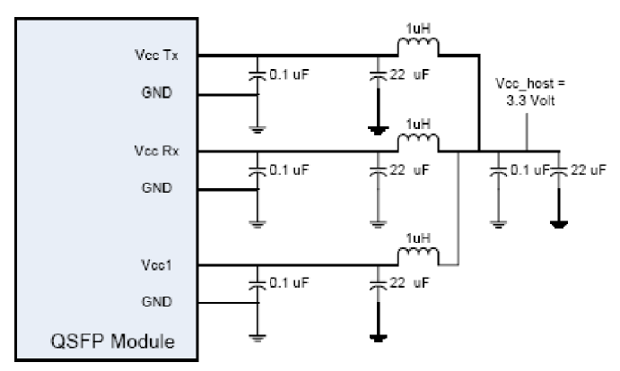

* + **Ordering information:**

|  |  |  |  |  |  |  |
| --- | --- | --- | --- | --- | --- | --- |
| **Part Number** | **Package** | **Rate** | **Fiber type** | **Distance** | **Wavelength**  **(nm)** | Temperature  **(℃)** |
| TM-OFFAx -443E | SFP28 | 40Gbps | SMF | 40km | 1310 | 0/+70 |

* + 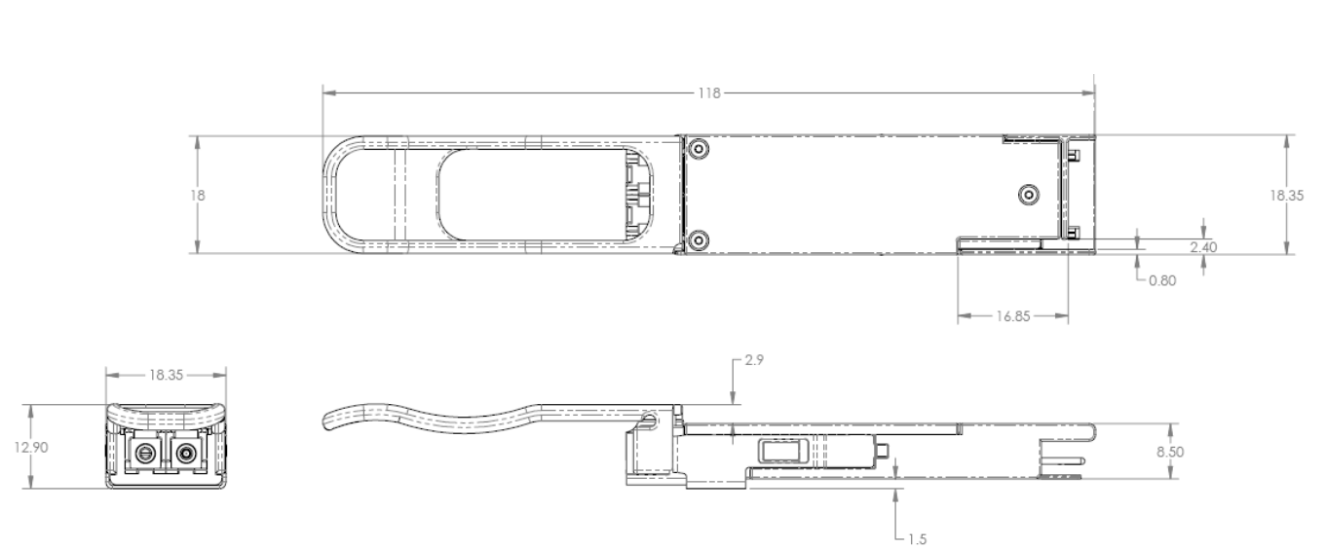**Mechanical Dimensions:**
  + **Recommended Interface Circuit**

